# If Else Conditions

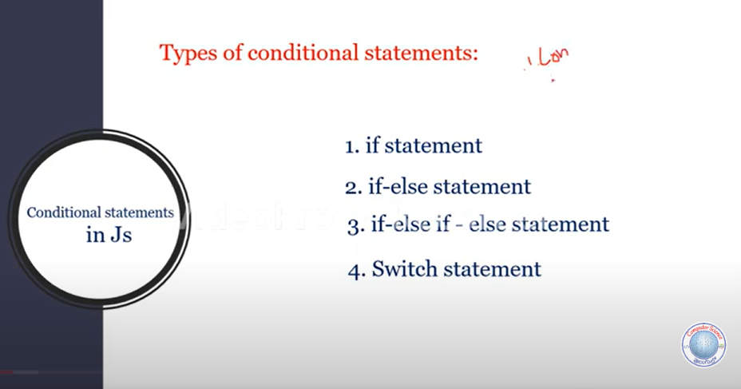

Promt function:

Promt function can take the use input and also display some message

Example: prompt(“Enter a number”);

**Switch Statement Syntax**

